Lab 1: Creating Dynamic Web Projects in Eclipse using Java Jakarta EE
Course: 420-941-VA – Web Services
College: CEGEP Vanier College
Student Name and #: [Moied Ahmed 1090065]
Date: [2025-09-09]

Each Project is accompanied by photo of servlet on glassfish server

1. WebHelloWorldProject1
I created a project named WebHelloWorldProject1 in Eclipse and added a package called webHelloWorld.
I created a servlet named WebHelloWorldServlet and mapped it to the appropriate URL.
In the servlet, I wrote code to display a simple HTML message in the browser.
I also created a University class and used it inside the servlet to show university details such as the name and location.
After completing the setup, I deployed the project on the GlassFish server and accessed it through the browser to confirm that the output was displayed correctly.

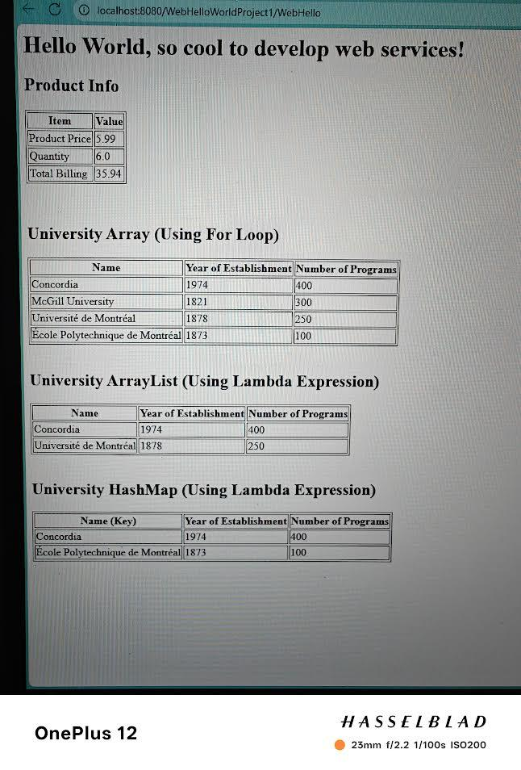

2. WebBillingProject1
I created a second project named WebBillingProject1 and added a package called webBilling.
I developed a class named Billing to store client names, product names, price, quantity, and tax values.
I included constructors, setter and getter methods, and a method to calculate the total billing including taxes.
Then, I created a servlet named WebBillingServlet, where I initialized three Billing objects and assigned values using setter methods.
I displayed the billing records in an HTML table format in the browser.
After deploying the project to GlassFish, I tested the output to ensure the table showed the correct data.
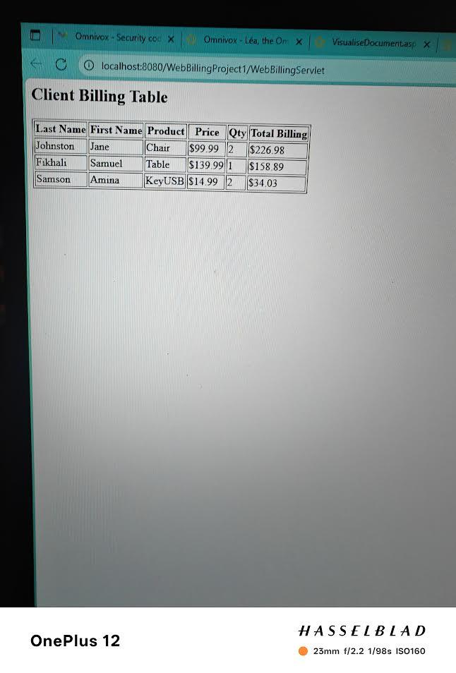

3. WebCourseProject
I created a third project named WebCourseProject and added a package called webCourse.
I created a class named Course with attributes for the course code, title, and number of credits.
Next, I created a servlet named WebCourseServlet, where I instantiated several Course objects and stored them in a list.
I then generated an HTML table in the servlet to display all the course details in the browser.
Finally, I deployed the project to the GlassFish server and confirmed that the course list appeared properly in the browser.

